Hillary Herald 27th September 2024



What a busy week in school. Y3 and Y4 have enjoyed their visit to Lincoln, our girls football team had their first match of the season and the whole school celebrated the European day of languages.

# Coming Up

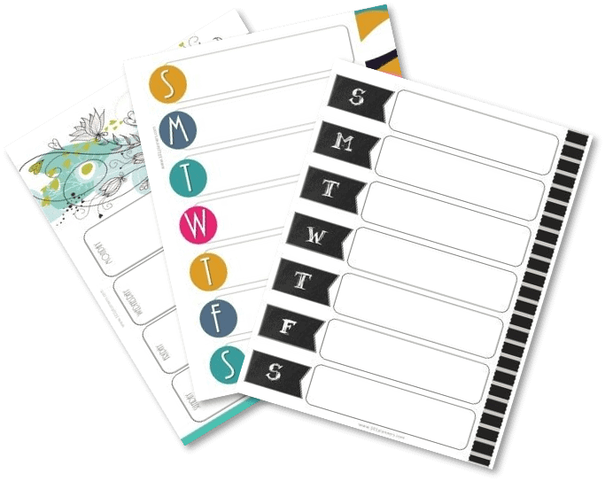

Tuesday 2nd October Harvest festival - Please donate tinned, dried or packet foods or toiletries. Thank you.

Tuesday 8th Oct - Parents Evening 4pm - 6:15pm

Wednesday 9th Oct - Parents Evening 4pm - 6:30pm

Tuesday 15th October -FS2-Y6 flu vaccinations

Friday 18th October Last day of school for half term holiday

Monday 4th November - First day back to school

# Our School News



# Y4 visit to Lindum Colonia (Roman Lincoln)

'I loved the tour around Lincoln . It was great to see the remains of Roman buildings that were over 2500 years ago.' Llewellyn Simmonds Y4

'I enjoyed the archeological dig  because I found lots of evidence that told me about life in the Roman times.'  Elliot Andoh - Kofie Y4

'I liked trying on real Roman armour. It was really inspiring getting to see the real artefacts.' Alfie Zielinski Y4

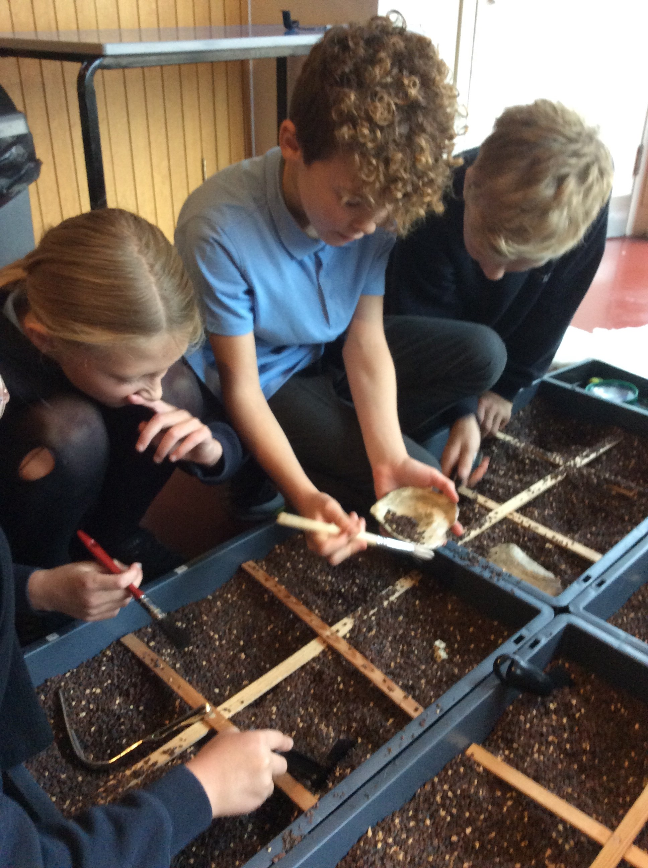

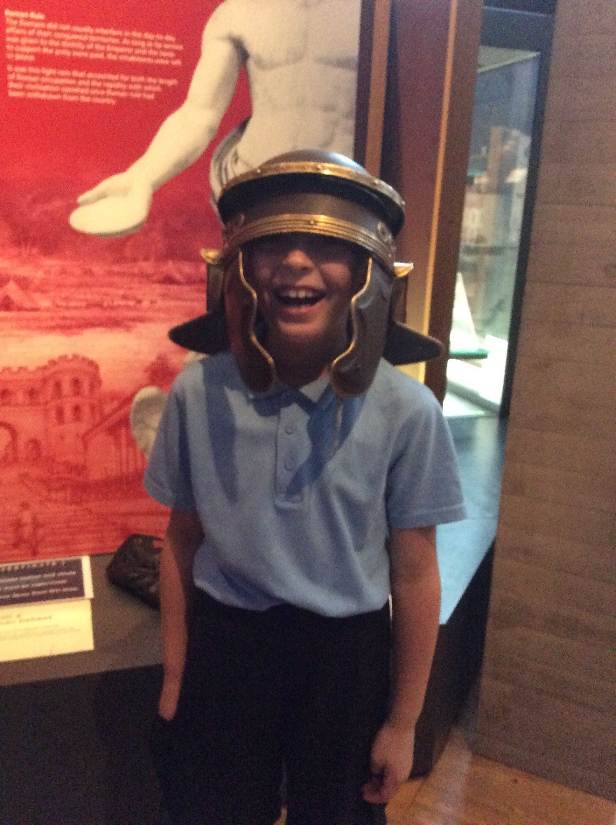

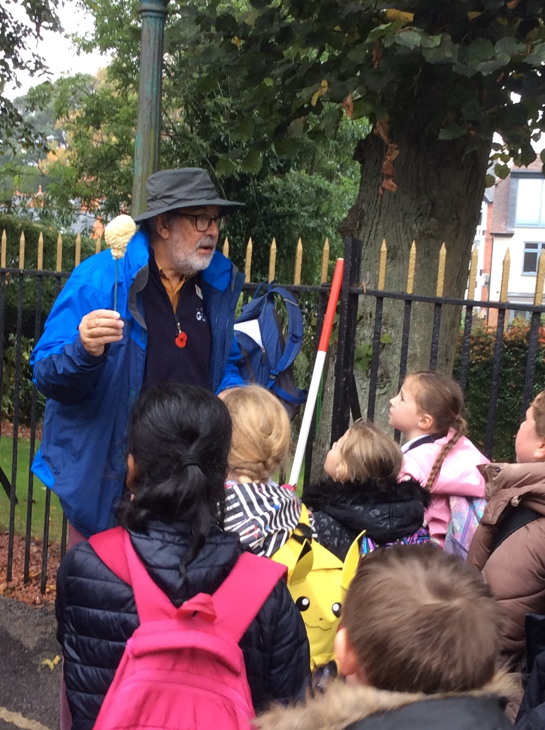

# Football



This week our girls took part in their very first football match, away against Carr Hill Primary school. You could feel the excitement and nerves as they left! Despite a hard fought battle on what I am told was a tough pitch, the girl were gracious in defeat. Well done girls a respectable (3-2). We look forward to hearing about your next match.

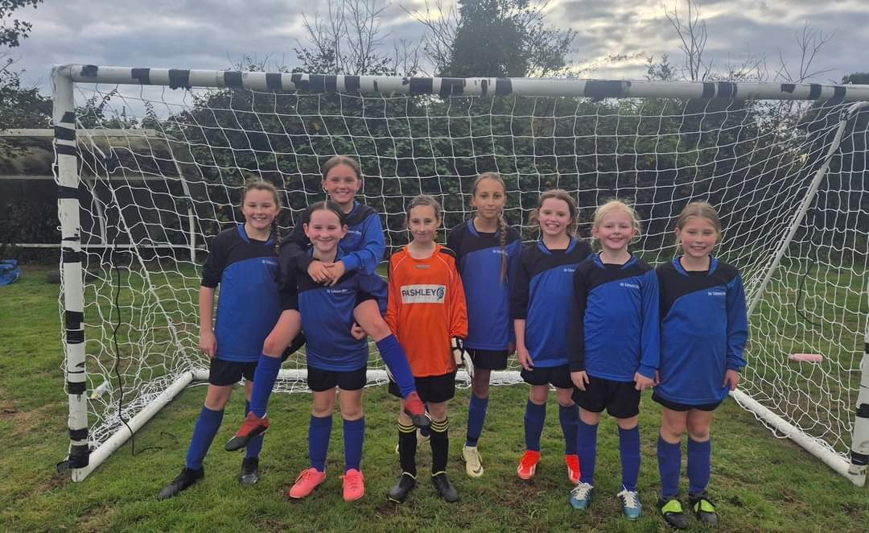

# European Day of Languages

This week we all celebrated the European day of languages. Every class took part in activities relating to a different European country. They dressed up in colours relating to their countries flag, they learn some common words and phrases, looked at customs and different traditions and the activity that caused most excitement, food tasting, many children were surprised by how many foods that they regularly eat come from different countries. Every one had a great day and learnt new facts about our wider global community.

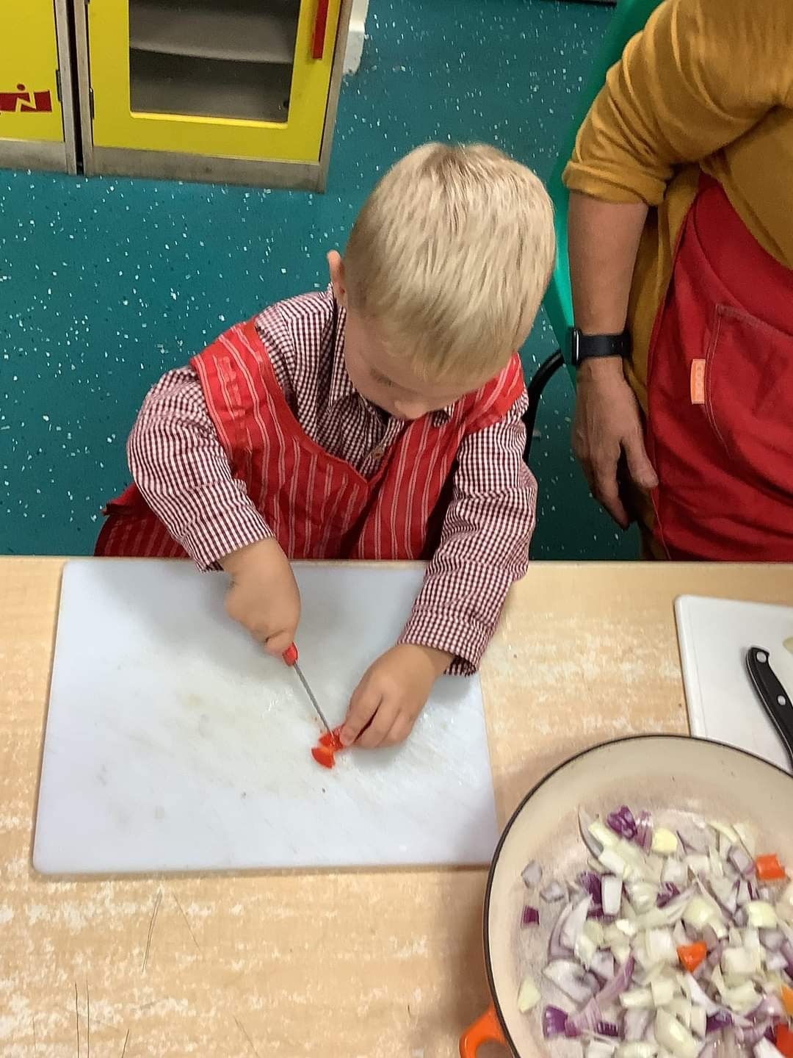

# CLIMBER of the Week



Our most prestigious award handed out on a Friday assembly is the climber of the week. This is awarded to a member of the class each week that had demonstrated the school values and shone above all others. This week's CLIMBERS are...

Elizabeth Pitel

Alexander Hall

Lola Burton

Eliza Sibson

Isabella Matthews

Jack Winfrow

Ellie Holt

Orla Gilling

Peaches Hopkinson

Joseph Scarborough

Charlie Smith

Thoedore Zielinski

Gavrial Gotu

Uniform.

It is great to see our children looking so proud of their uniforms. We have had some lovely comments from members of the public about how smart they look whilst on trips over the last couple of weeks.

A reminder though that footwear is black shoes that can be polished. No trainers or pumps other than for PE.

# Online and phone safety





