Hillary Herald 23rd September 2024



Welcome to the first of this year's Hillary Herald. Every week we will share some key information about upcoming events and share some wonderful learning that the children have engaged in.

The children have settled well back into school and are looking smart and ready for learning in their new school uniforms. We are proud of how they embody our school values every day.

# Coming Up

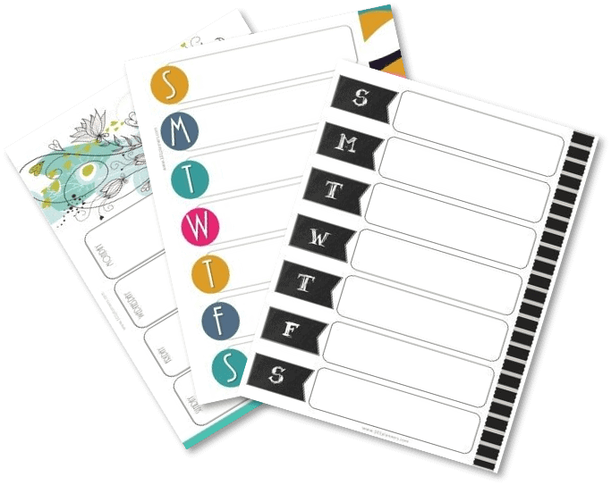

Monday 23rd September - Y4 visit to Lincoln

Tuesday 24th September -Y3 visit to Lincoln

Thursday 26th September European Day of Languages.

Tuesday 2nd October Harvest festival - Please donate tinned, dried or packet foods or toiletries. Thank you.

Tuesday 8th Oct - Parents Evening 4pm - 6:15pm

Wednesday 9th Oct - Parents Evening 4pm - 6:30pm

Tuesday 15th October -FS2-Y6 flu vaccinations

PLEASE LOOK OUT FOR SIGN-UP SHEETS FOR PARENT CONSULATIONS ON CLASSROOM DOORS FROM THURSDAY 26th September.

# Our School News



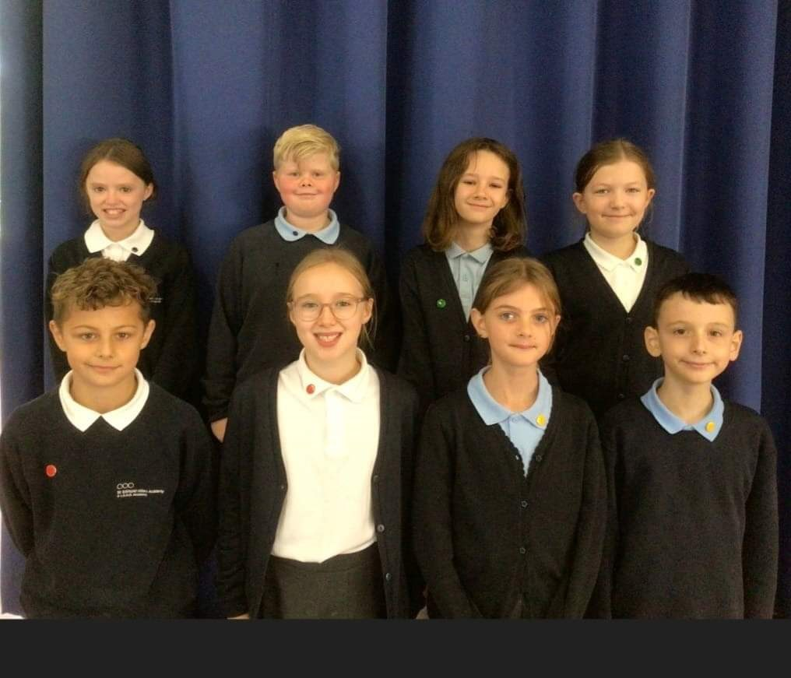

This week has seen democracy at work! We have seen the appointment of our colour team captains. They underwent a rigorous process of applying for their positions and explaining why they were the best person for the job. They are already demonstrating their leadership qualities by being responsible and kind pupils around school.

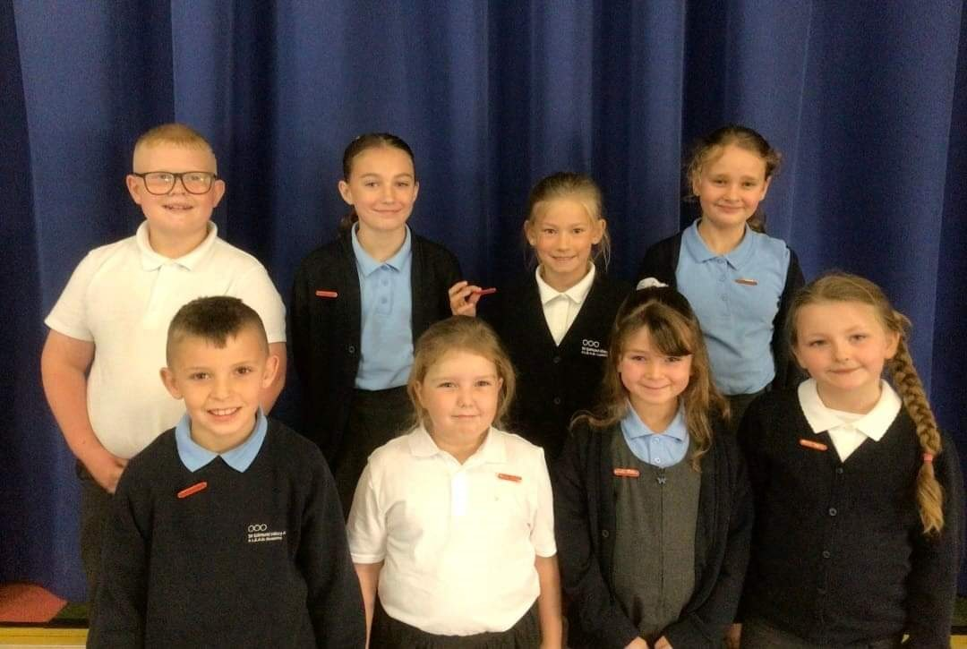

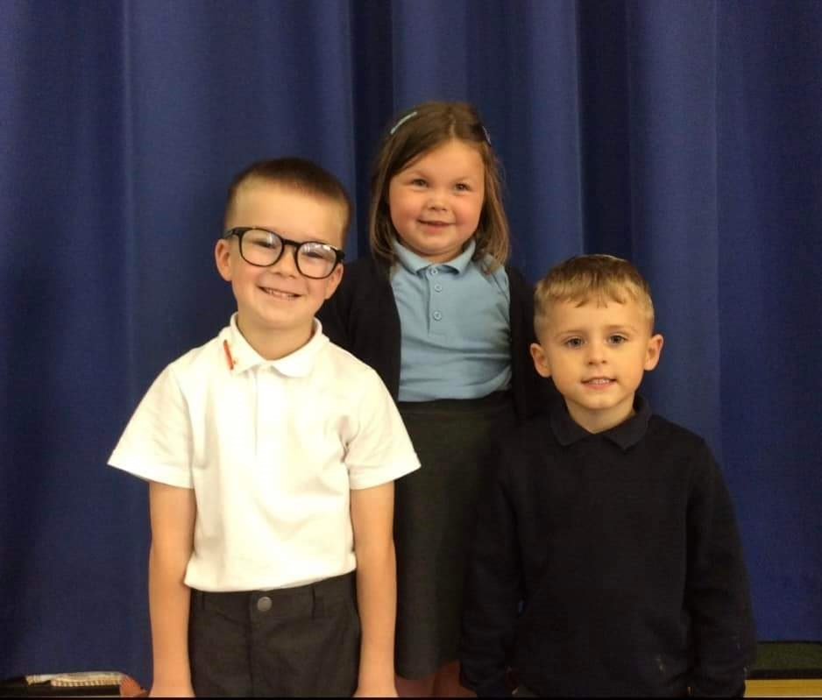

As well as our Team captains, each class from Y1 to Y6 elected their school council representative. Pupils from each class nominated themselves and completed a written application for the job. They then gave their campaign speech and their class voted. The children have an important role in school, they represent Sir Edmund Hillary in our community and strive to make improvements in our school. I look forward to seeing all that they achieve.

Our final Y6 appointments this week are our Head Boy and Head Girl. Many congratulations to them both. They are both shining examples of our school values. They work hard and never give up, they work hard at their learning and include others in all they do. They are kind and considerate members of our school and wider community.

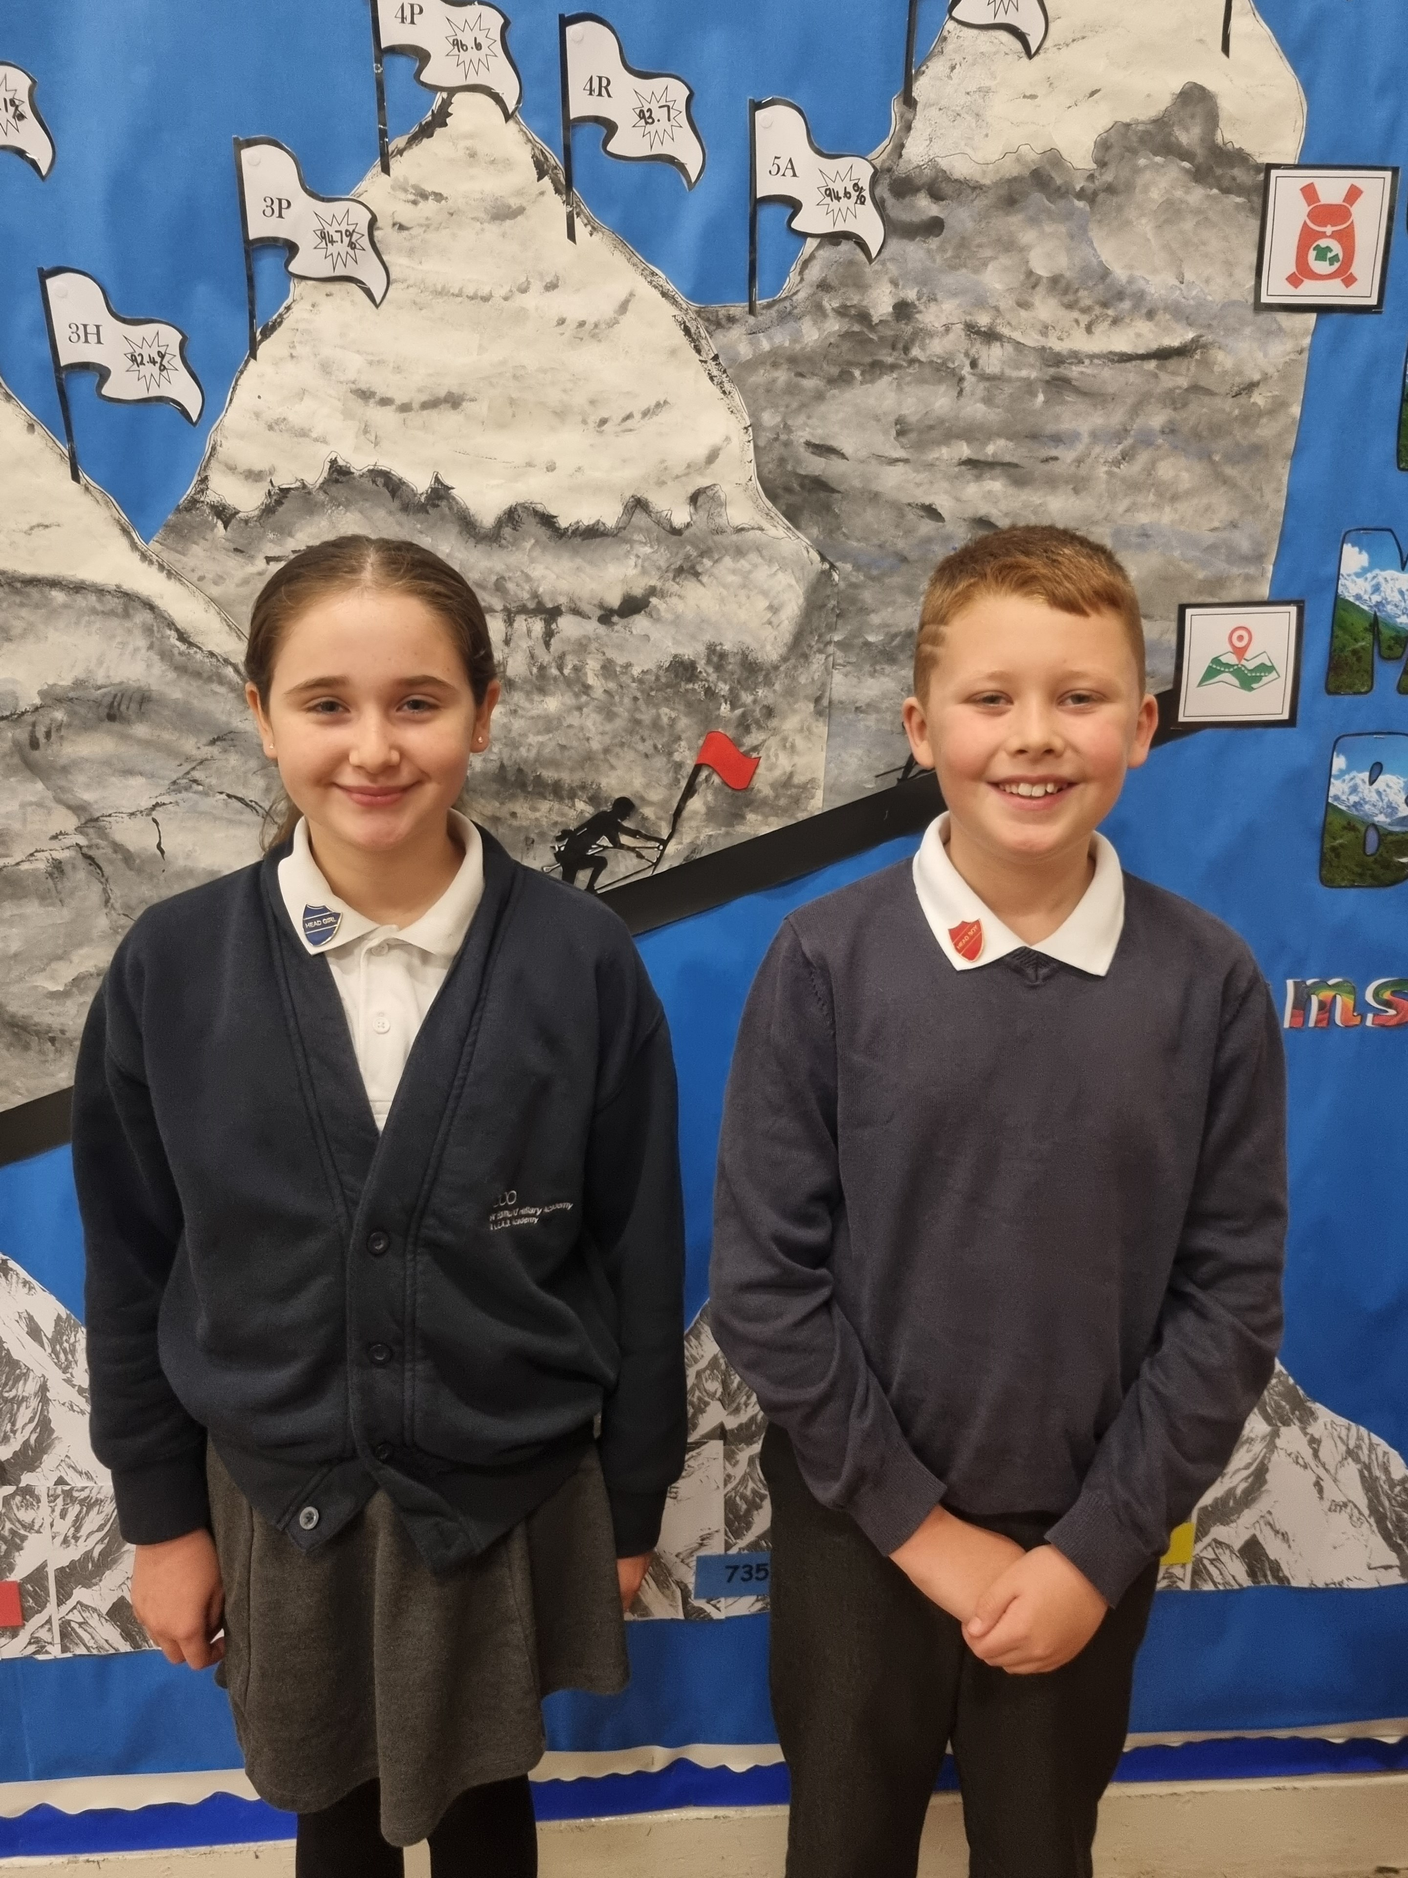

# CLIMBER of the Week



Our most prestigious award handed out on a Friday assembly is the climber of the week. This is awarded to a member of the class each week that had demonstrated the school values and shone above all others. This week's CLIMBERS are...

F2B - Harmony-Ann Hanrahan

F2G -Noah Keith

1T - Nancy Woodward

1/2M -Enzo Stones

2T - Harlie Cairns

3P - Connor Pearce

3H -Ivy- Beau Morris

4P- Abisha Sasikumar

4R-Eloghosa Idahor

5F - Shaine Ncube

5A- Samuil Pitel

6C- Juliana Jils

6P- Reece Ansell

# National Space Centre

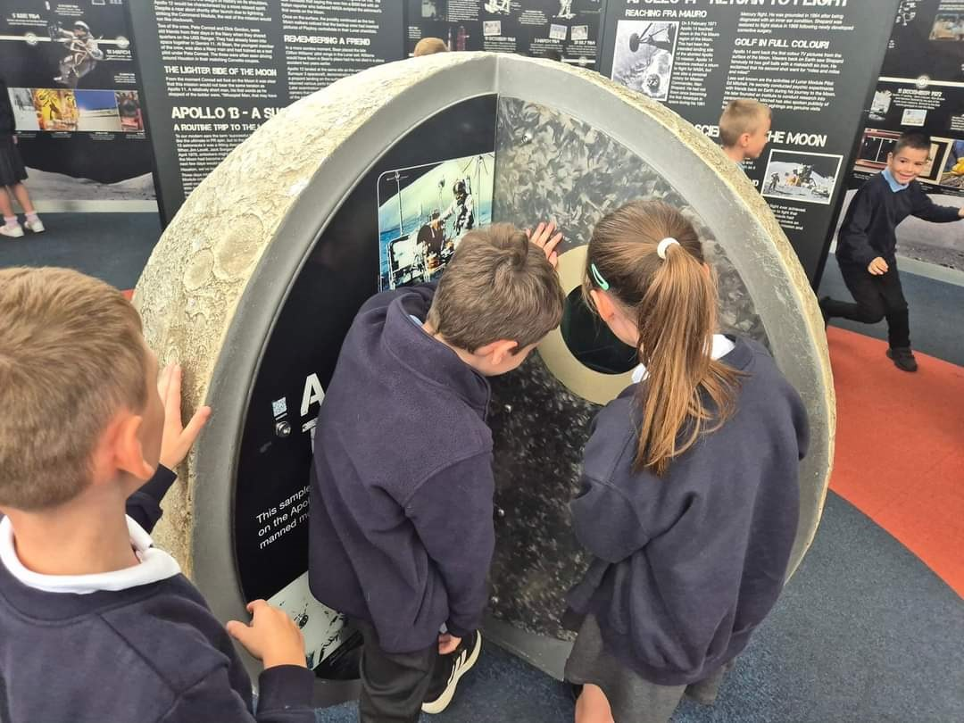

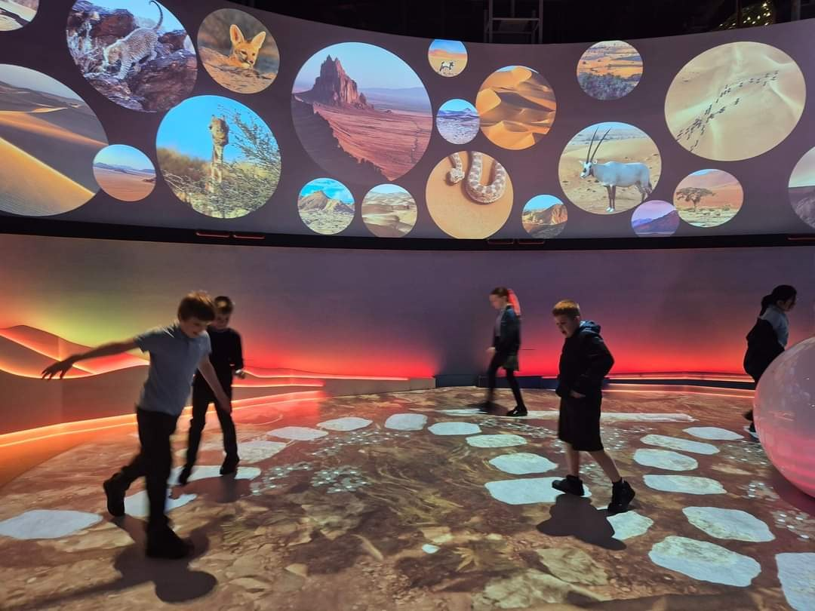

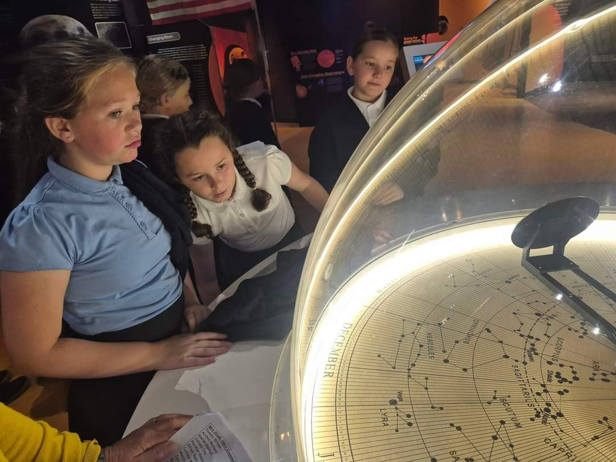

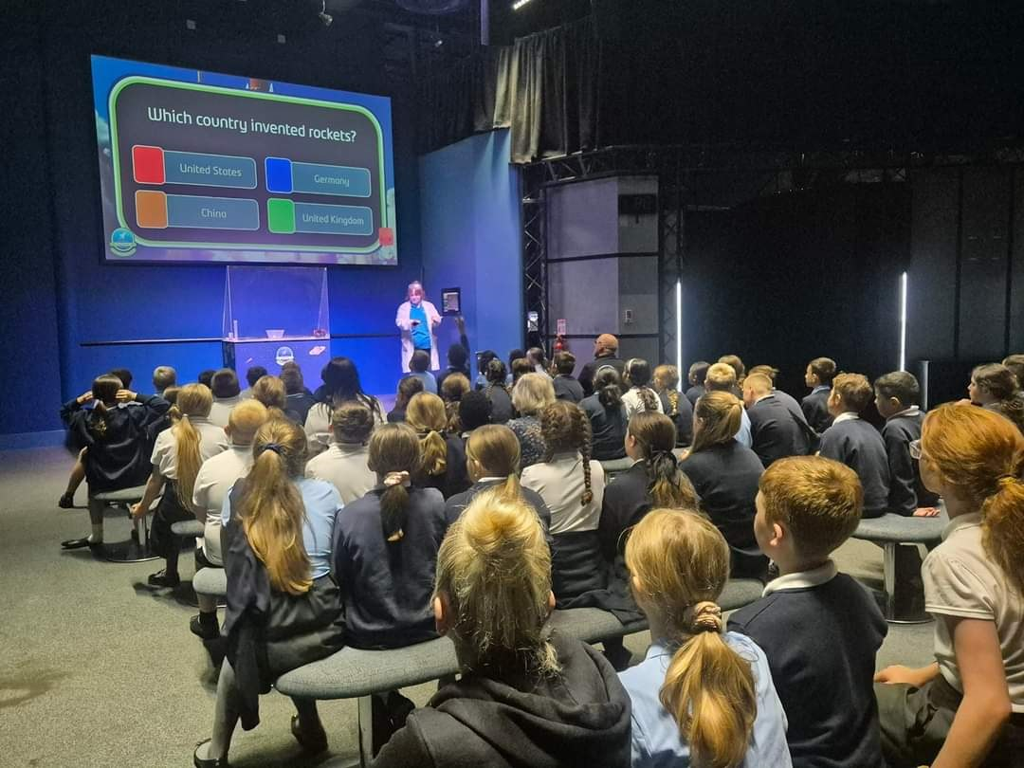

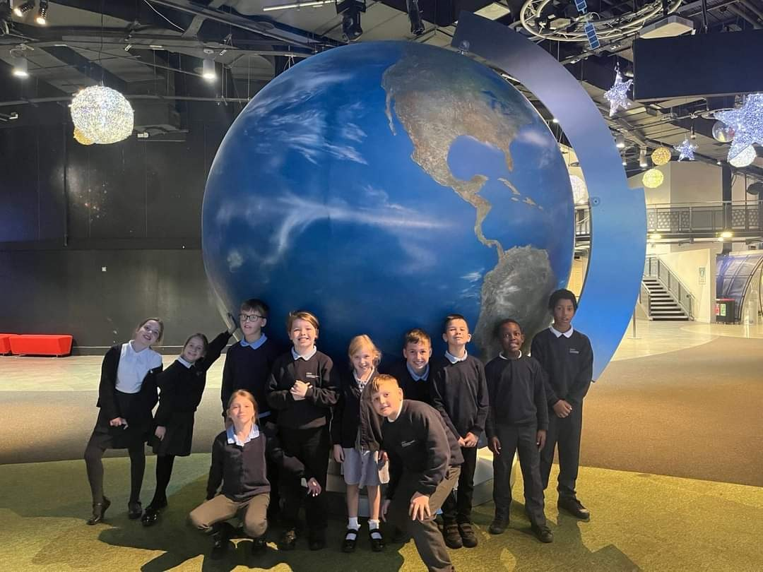

Our Year 5 and Year 6 children visited The National Space Centre in Leicester last week. They came back telling everyone that would listen that it was 'out of this world'. Maybe someone will be inspired to be an astronaut or astrophysicist in the future.

# Weekly Attendance



Whole school weekly Attendance is 95.3%

This weeks winners of the boots are.....

Highest attendance in FS is F2B with 96.5 %

Highest attendance in KS1 is 1/2M with 98.5%

Highest attendance in UKS2 is 5F with 100%

# Online and phone safety

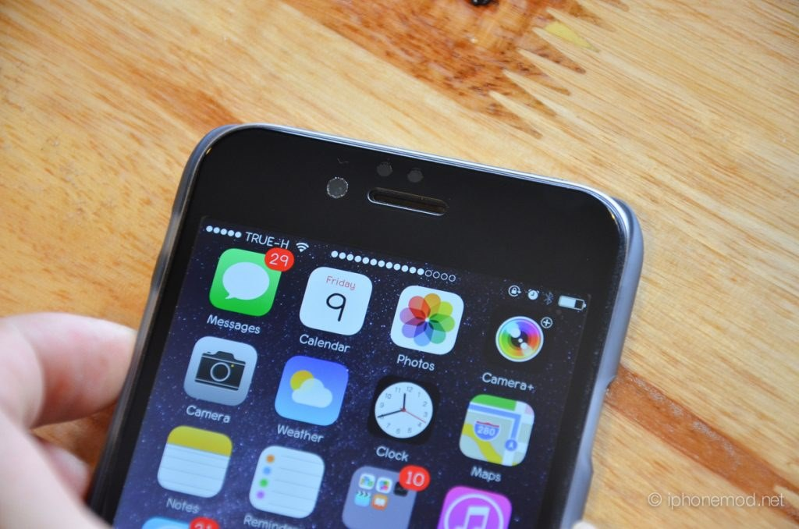

A reminder that children should not have mobile phones in school. They are expensive and often unnecessary and they should only be brought to school if absolutely necessary. Children are not permitted to use them on the school grounds and must be handed in.