** Nursery Newsletter - Autumn 2**

Look out for our **Rhyme of the fortnight** handouts, which give you the words for our key songs and rhymes. Please sing and enjoy them together at home, helping your child to learn the words.

**Diary Dates**

**First** **day of term:** Monday 6th November **Last day of term:** Friday 22nd December **Christmas Party:** TBC

**Learning at home:**

· Go for a woodland walk and talk about what you can see.

· Take part in our Autumn treasure hunt.

· Throw and kick Autumn leaves and talk about the colours.

· Carve a pumpkin together.

· Build a den with your child using blankets and sheets.

Also encouraging your child to put their own coat and shoes on will help them become more independent and give them a sense of pride in their achievement.

**Sharing books**

**Reading stories to your child is vital**. Find a quiet time to enjoy a book together. Encourage children to join in with words like “Too bouncy”. Re-reading books lots of times is very important and helps children remember stories.

Going to the library regularly and borrowing books is a great routine to get into. Worksop Library is a fantastic place to visit with your child and a great way to support your child’s learning for free.

**Speaking**

Supporting your child’s speaking skills is the most important way you can help your child to learn. Make time to talk to your child, comment on what you are doing, reduce questions and give your child time to talk. Teach them new words. Good words to use at home linked to our Autumn theme are:

**Hedgehog, leaves, tree, hibernate, orange, dark, sleep, cold, windy, frost**

Check out the BBC Tiny Happy People website for advice and activity ideas: here is the page for 2-3 year olds…



**The stories we will be focusing on are:**

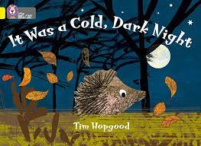

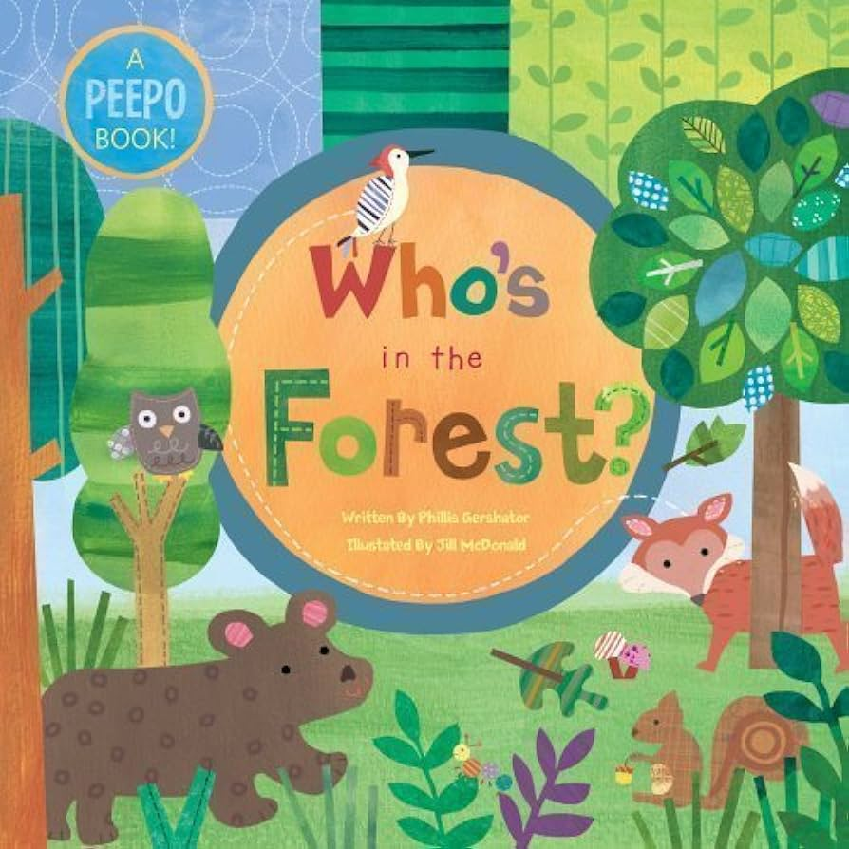 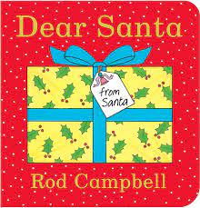

 Next half term we learn all about Autumn! We will learn about hedgehogs and woodland animals, how to look after living things, changing of the seasons and Autumn colours (red, orange and brown). We will make a hedgehog home and children will practise putting their own coat on. As we move into December, our learning will focus around Christmas with colourful, sensory activities to provoke wonder and excitement.