**Foundation 1 Newsletter – Summer 1**

‘**Ideas to support this topic at home:**

Have fun in the garden together….

- Make mud pies using old pots and pans. Talk to each other about what you are making and get messy!

- Make a daisy chain. How long can you make it? How many daises did you use?

- Look under rocks and logs: what creatures can you find? Talk about what you can see as you hold them gently.

- Draw pictures and write names on the floor with chalk or a paintbrush and water.

- Help your child to develop an understanding of the passing of time by looking at family photos together, talking about what your child was like as a baby and looking at baby photos of you!

 - Talk about what day it is and help your child learn the days of the week in order.

**Worksop Library**

If you aren’t members of Worksop Library yet, please go and sign up. Looking at books together and sharing stories is one of the best ways that you can support your child’s education. Why spend lots of money when you can borrow books for free! You could look for books about frogs or growing plants—stories or information books. Allow your child to spend time looking at the front covers of books, talk about the titles and what books might be about. Plus, children get a lot out of visiting places in the local community and learning about the place where they live.

Time certainly is whizzing by; Summer Term is almost here! Our next focus is on ‘Growth and Change’,

starting with frogs and their life cycle. After that, we will learn the ‘Jack and the Beanstalk’ story and have a go at growing our own beanstalks and other plants. We will also spend some time thinking about how people grow and change. We will encourage children to care for all living creatures, particularly bugs and insects, as we explore outside.

**Diary Dates**

**First day of term:** Monday 15th April

**Last day of term:** Thursday 24th May

Our ‘Wow Words’ for this topic are:

**frogspawn, tadpole, frog, change, grow, plant.**

Use these words in conversation at home - children learn words when they hear them over and over again.

**The books we will be focusing on are:**

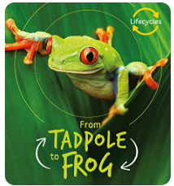 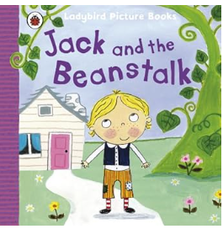

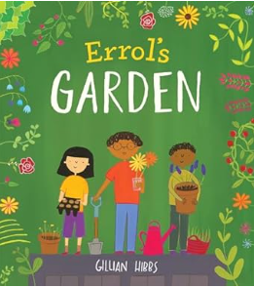

**Looking after your child’s teeth.**

It is very important to look after your child’s teeth and to teach them about brushing and other ways to keep teeth healthy.

Dental problems will impact on your child’s health and wellbeing. Children who have toothache or who need treatment may have pain and difficulties with eating, sleeping and socialising.

Shockingly, a quarter of 5-year-olds have tooth decay when they start school.

Dentist appointments are free to all children, so please book an appointment for your child to have a check-up if they have not had one in the last 6 months.

This flier gives very good advice:

