** Foundation 1 Newsletter – Spring 2**



‘**Goldilocks and the Three Bears’ play ideas for home:**

·Play with dry porridge together: scooping, filling and making porridge for the bears.

· Make delicious porridge together, talking about each step of the process. What toppings will you add?

· Go on a walk in the woods, what can you find? Talk about animals that live in the woods. Can you find any plants growing?

· Look for big, small and medium sized things (you could compare the size of everyone’s shoes or socks!).

· Sing the Goldilocks song together:

**NHS Start for Life**

Did you know that **90%** of your child’s brain growth takes place before they turn 5? What you do together can make a huge difference and supporting your child’s speaking skills is the top priority.

The **NHS Start for Life** website has some really useful

advice, tips and video clips to help you with all things

pregnancy, baby and young child related.

The QR code here takes you to their page about

‘**Learning to talk: 3-5 years’.**



**Diary Dates**

**First day of term:** Monday 18th February

**Last day of term:** Thursday 28th March

Our ‘Wow Words’ for this topic are:

**huge, medium-sized, terrified, fierce, construct, season and spring.**

Use these words in conversation at home - children learn words when they hear them over and over again.

**The stories we will be focusing on are:**

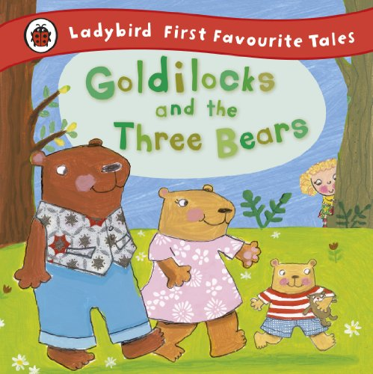 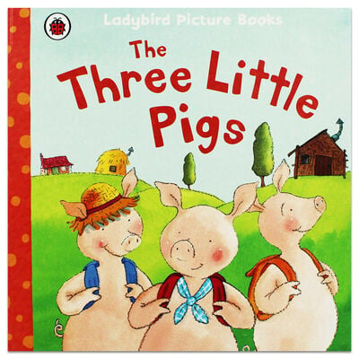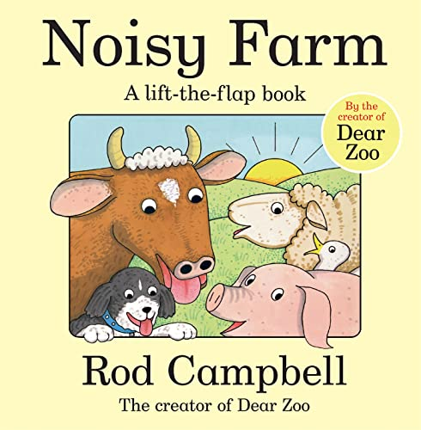

**Can you believe it, we are half way through the school year! Time flies when you’re having fun!** This half term our learning is focussed around the story of Goldilocks and the Three Bears, followed by The Three Little Pigs. By this time Spring will be in the air (hopefully!) and we can learn about the new season and Easter.

**Traditional Tales**

Enjoy lots of stories together! If you don’t have the likes of The Billy Goats Gruff, Goldilocks or Jack and the Beanstalk at home, you could borrow them from the library, search the internet for video stories or just retell them to your child without a book!

Traditional stories have lovely repetitive language in them that really supports children’s understanding of the text. Aim for your child to be able to retell the story back to you.

Encourage your child to sometimes be the one to turn the pages and show you where to start reading on the page.