**Foundation 1 Newsletter – Spring 1**



**Try these ideas when learning about winter at home…**

* Make ice cubes or bigger blocks of ice using plastic tubs and then add them into the bath to melt!
* Go on a winter walk together. Talk about needing warm winter clothes, the weather and how some animals hibernate in the winter.
* Feed the birds. Make a fat ball by mixing lard and seeds and pressing it onto a pine cone. Hang it outside and watch for the birds! How many can you see?
* Make hot chocolate or soup together!
* If it snows, make a snowman and snow angels!

·

Teaching your child to understand and use new words is really important. Our ‘Wow Words’ for this topic are: **melting, frozen, change, weather, hibernate.** Use these words in conversation at home—children learn words when they hear them over and over again.

**The stories we will be focusing on are:** 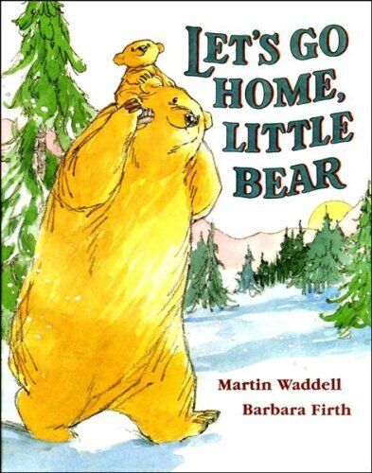 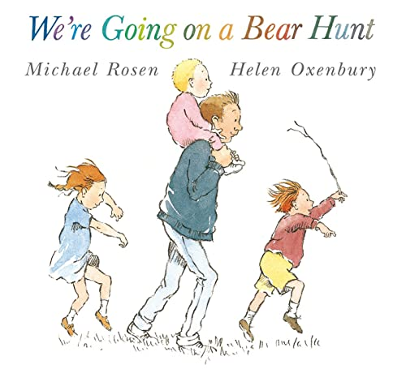



Next half term we learn all about winter. We will learn about the weather and explore ice, and hopefully snow! The children will continue to access our outdoor learning environment so please make sure they come with a warm coat and hat and that they are well practised at putting their own coats on!

**Diary Dates**

**First day of term:** Monday 8th January

**Last day of term:** Friday 9th February

**Learning about Emotions**

Understanding and managing emotions is really important for the development and wellbeing of children. Learning how to recognise and name emotions helps children to learn about their own and other people’s feelings.

At school we use a technique called Emotion Coaching to help children to name feelings and think about behaviour choices.

This page on the Tiny Happy People Website has lots of short clips, with tips and advice related to your child’s emotional development.



**Nursery Rhymes**

Look out for our **Rhyme of the Week** handouts, which give you the words for the rhymes we’ve been learning in school. Please sing and enjoy them together at home, helping your child to learn the words.

Little Wandle have some lovely videos for 20

different nursery rhymes. You can access the

videos through the parent’s page of the site,

or using this QR code.