**Foundation 1 Newsletter - Autumn 2**

**Diary Dates**

**School Trip to Perlethorpe:** Friday 15th December **Foundation Nativity:** Tuesday 12th December

**Last day of term:** Friday 22nd December

**Learning about fire safety at home:**

· Check your smoke alarm together and talk about what to do if the alarm sounds.

· Talk about how adults ring 999 in an emergency.

· Teach your child to remember their home address, including the number they live at.

· Talk about things that are hot and dangerous at home like radiators, the fire, the cooker

· Pretend to be fire fighters together. You could build a fire station den or a fire engine and race to emergencies together!

**Speaking**

Supporting your child’s speaking skills is the most important way you can help your child to learn. Make time to talk and encourage them to hold conversations rather than just answering questions. Teach them new words. Good words to use at home linked to our firefighter theme are:

**extinguish, emergency, dangerous, siren, protect and brave**

Check out the BBC Tiny Happy People website for advice and activity ideas: here is the page for 3-4 year olds… 

**Sharing books**

**Reading stories to your child is vital**. Find a quiet time to enjoy a book together. Encourage children to join in with words like “I’ll huff and I’ll puff…”. Re-reading books lots of times is very important and helps children remember stories.

Going to the library regularly and borrowing books is a great routine to get into. Worksop Library is a fantastic place to visit with your child and a great way to support your child’s learning for free.

Look out for our **Rhyme of the Week** handouts, which give you the words for our key songs and rhymes. Please sing and enjoy them together at home, helping your child to learn the words.

**The stories we will be focusing on are:**

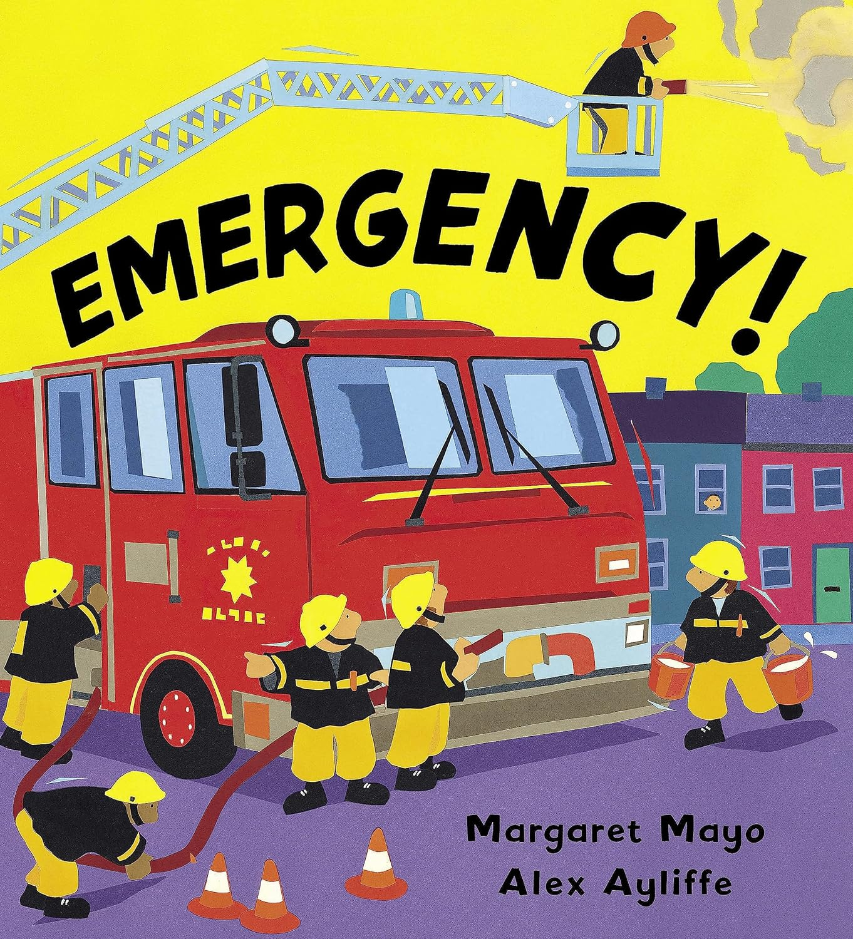 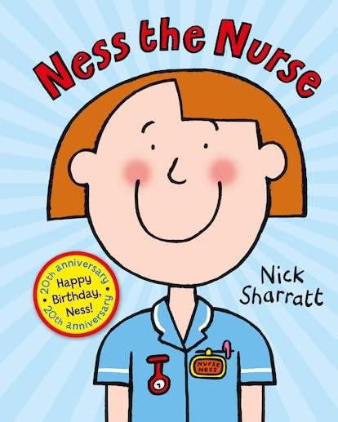

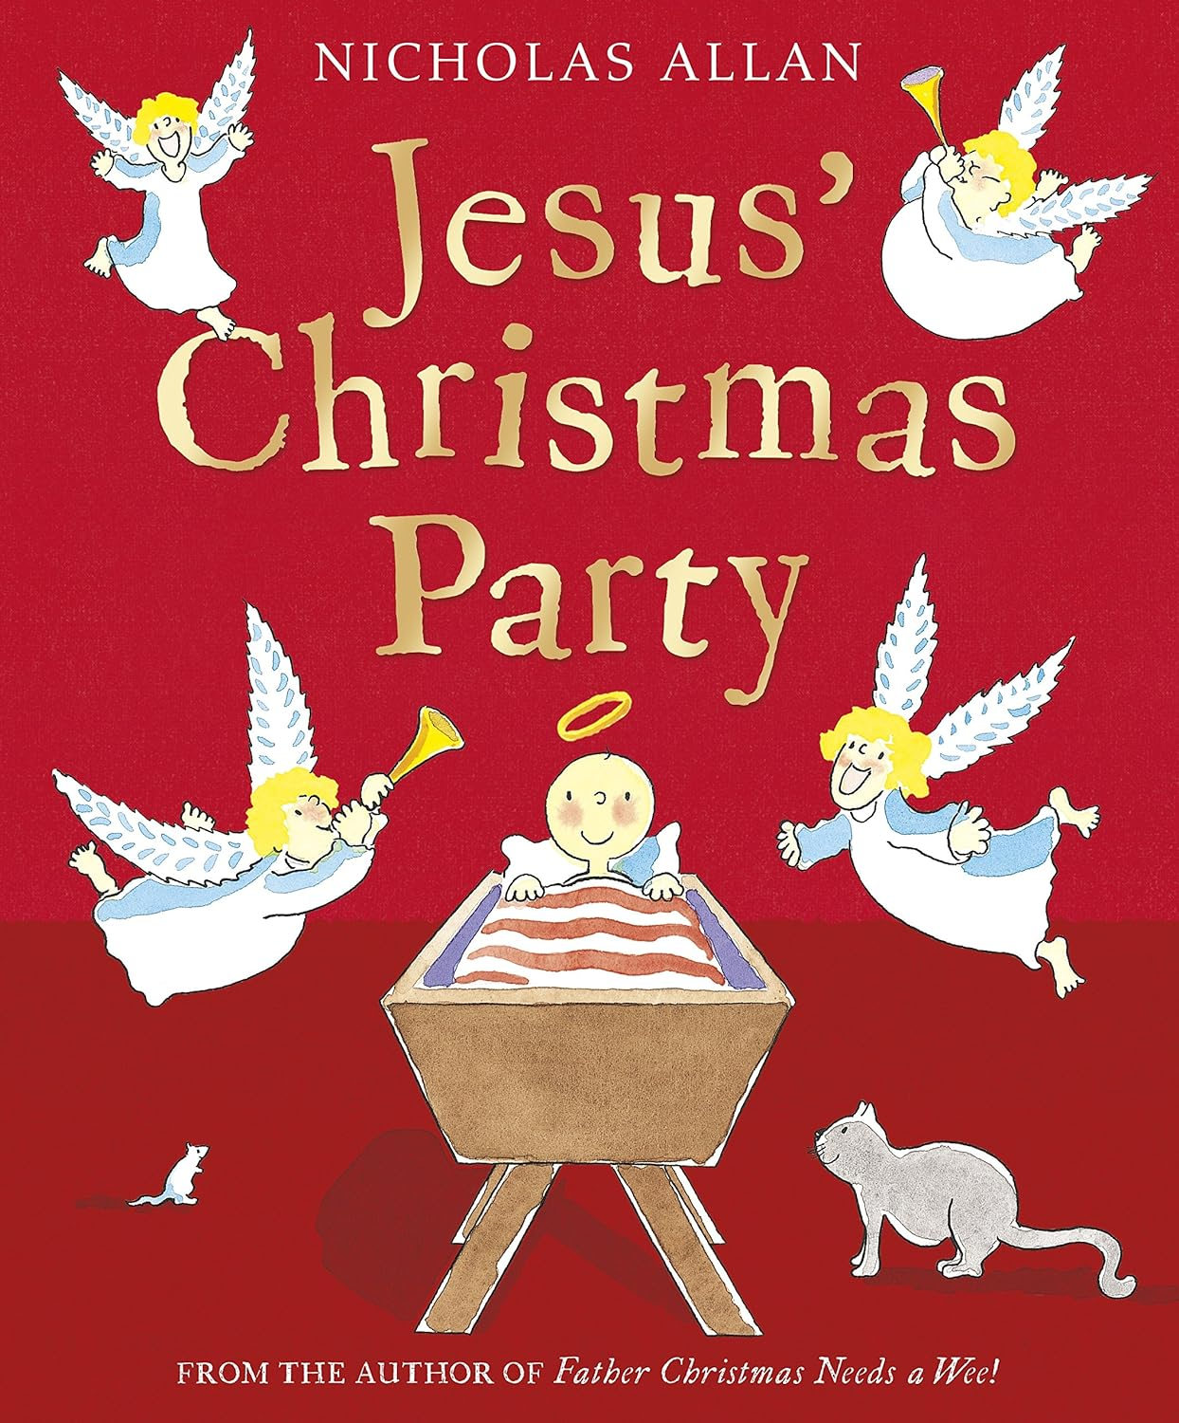

Next half term we learn all about People Who Help Us! We will learn about the role of fire fighters, vets, doctors and nurses. Worksop Fire Brigade will come to visit us! As we move into December, our learning will focus around Christmas and The Nativity Story.